Move Until Near: Final Quiz (10 Pts)

Name(s)________________________ Date__________

Answer each question below by including the question in your answer statement. An example would be, “What color was the red car?” Ans: “The color of the red car was red.” Use one piece of notebook paper for the team

1. How many blocks make up the basic version of Forward Until Near, and which blocks are they? (2) 3 TWO MOVE BLOCKS AND ONE WAIT BLOCK

2. What does the unlimited Move Block do differently from the rotations, degrees, or seconds versions? (1) ) IT WILL NOT TURN THE MOTORS OFF

3. Explain what is meant by a threshold. (2)A THRESHOLD IS A CUTOFF VALUE THAT SEPARATES A SET OF VALUES INTO TWO CATEGORIES

4. Explain how the NXT, using an ultrasonic sensor, detects when it should stop? (2) THE ULTASONIC SENSOR USES THE SPEED THAT SOUND WAVES TRAVEL TO MEASURE DISTANCE TO AN OBJECT. ONE OPENING IN THE FRONT SENDS THE ULTRASONIC WAVES AND THE OTHER RECEIVEDS THEM THE SENSORS MEASURES HOW LONG IT TAKES FOR THE WAVE SENT OUT TO BOUNCE BACT TO THE SENSOR

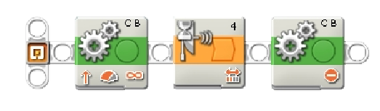
5.Explain the basic behavior that will occur with the programs shown below. (3)

THE ROBOT WILL MOVE FORWARD UNLIMITED
WAIT AT A CERTAIN DISTANCE
STOP

